
SYMBIOSIS INSTITUTE OF TECHNOLOGY, PUNE
Symbiosis International (Deemed University)
(Established under section 3 of the UGC Act, 1956)
Re-accredited by NAAC with ‘A’ grade (3.58/4) | Awarded Category – I by UGC
Founder: Prof. Dr. S. B. Mujumdar, M. Sc., Ph. D. (Awarded Padma Bhushan and Padma Shri by President of India)

Assignment No. 12

Subject: | DevOps Lab
TCODE: | TE7950
Name of Student | Yash Patel
PRN No. | 23070122235
Branch | CSE, Batch (2023-27), L4
Academic Year &  Semester | 25 – 26, Sem VII
Date of Performance | 23rd July, 2026
Title of Assignment: | Kubernetes Pod & Deployment
Theory: | Kubernetes is an open-source container orchestration platform used to automate the deployment, scaling, and management of containerized applications. A Pod is the smallest deployable unit in Kubernetes and contains one or more containers that share the same network and storage resources. A Deployment manages Pods by maintaining the desired number of replicas, automatically replacing failed Pods, and supporting updates without downtime. Kubernetes simplifies application management by ensuring high availability, scalability, and efficient resource utilization across a cluster.  Commands Used  - Checked the Kubernetes client version:  kubectl version --client  - Verified the Kubernetes cluster information:  kubectl cluster-info  - Displayed the available cluster nodes:  kubectl get nodes  - Created the Kubernetes Deployment from the YAML manifest:  kubectl apply -f web-deployment.yaml  - Listed the running Pods:  kubectl get pods  - Deleted the Kubernetes Deployment and its Pods:  kubectl delete -f web-deployment.yaml
Implementation: | Step 1: Enable Kubernetes in Docker Desktop  Enabled Kubernetes — Enabled Kubernetes in Docker Desktop and verified that the local Kubernetes cluster was successfully initialized.  Step 2: Verify kubectl  Verified Kubernetes Cluster — Verified that the local Kubernetes cluster was running successfully using kubectl cluster-info and confirmed that the control-plane node was in the Ready state using kubectl get nodes.  Step 3: Create the Kubernetes Deployment YAML  Created Kubernetes Deployment Manifest — Created the web-deployment.yaml file inside the k8s-manifests directory, defining a Kubernetes Deployment with two replicas of the Flask web application using the Docker image my-flask-app:v2.  Step 4: Apply the Deployment Manifest  Applied Deployment Manifest — Applied the Kubernetes Deployment manifest using kubectl apply, creating the Deployment resource in the local Kubernetes cluster.  Step 5: Verify the Pods  Verified Running Pods — Verified that the Kubernetes Deployment successfully created two running Pods, each hosting an instance of the Flask web application.  Step 6: Clean Up  Deleted Kubernetes Deployment — Removed the Kubernetes Deployment and the Pods it created using the kubectl delete command, cleaning up the local Kubernetes cluster.  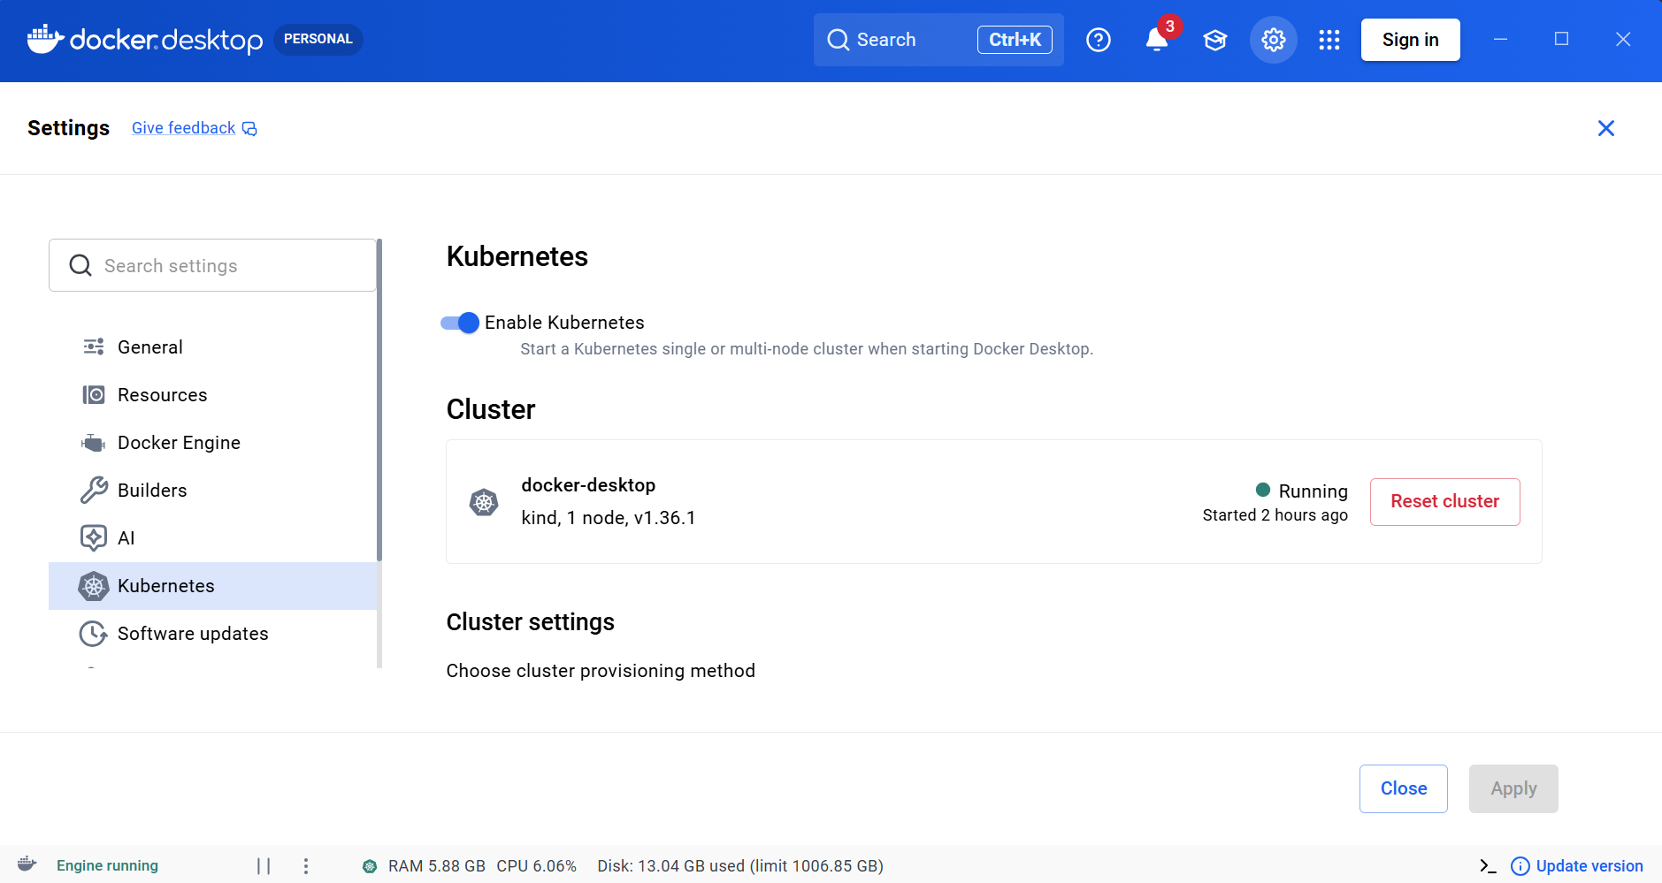  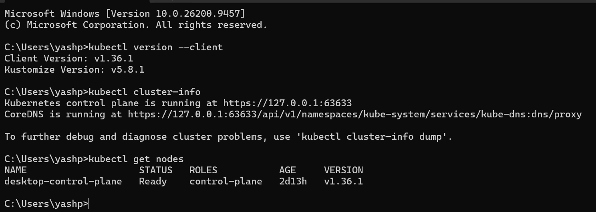  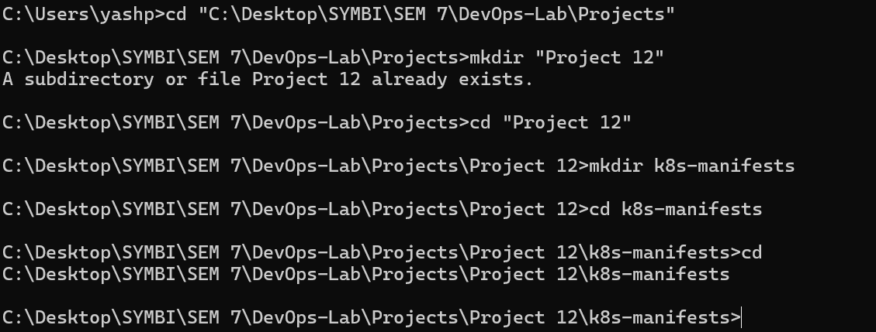  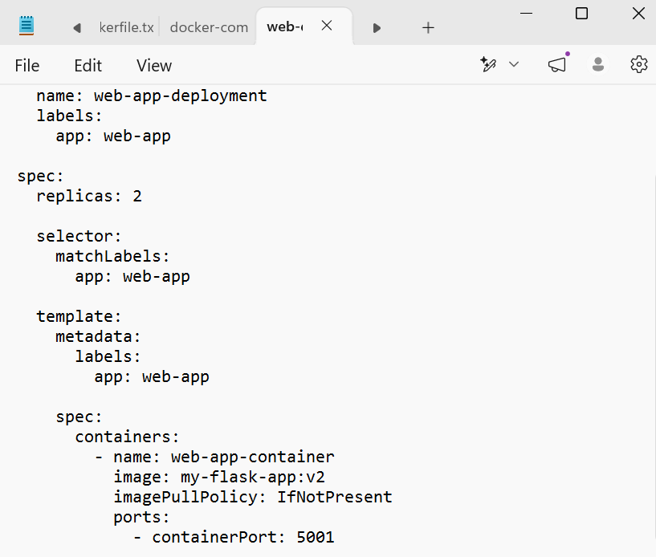  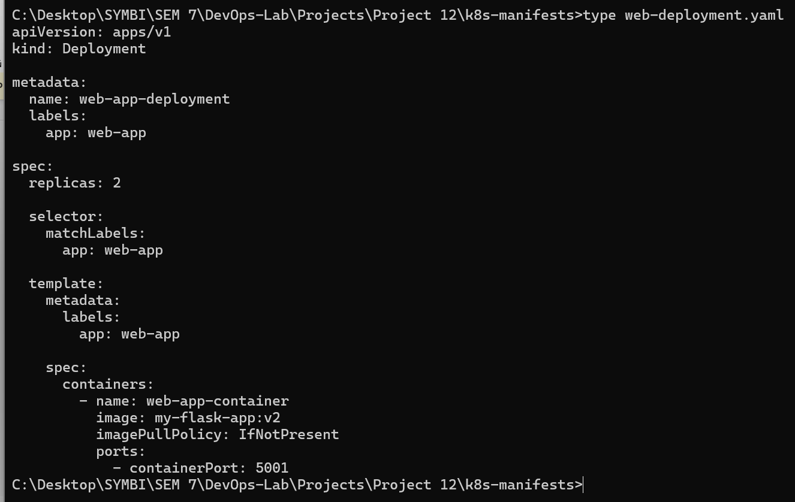  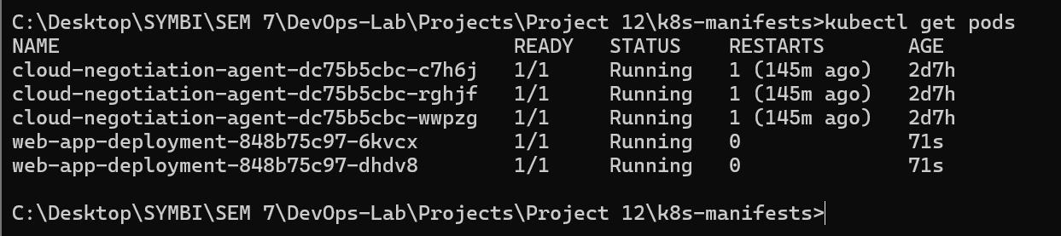  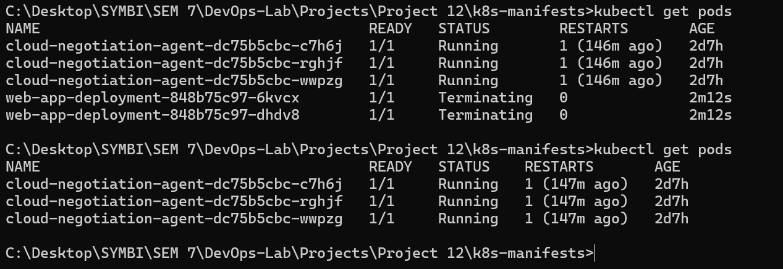

Subject Faculty Name: Prof. Arijit Dutta

